

**UNIVERSITY OF PETROLEUM & ENERGY STUDIES**

**SCHOOL OF COMPUTER SCIENCE**

***Department of Cybernetics***

**GRAPHICS AND ANIMATIONS TOOLS**

LAB FILE

SESSION (2020-21)

Course: BTech with specialization in Open Source & Open Standards

Submitted to: Submitted by:

Dr. Durgansh Sharma Surabhi Kumari

Associate Professor SAP: 500063663

Department of Cybernetics Roll no: R100217101

**Experiment-10**

Design of Building using Blender

STEP 1: Open Blender.

STEP 2: Create a new file -> Delete the default cube.

STEP 3: Insert a new cube

STEP 4: Scale and extrude it to create a platform which will act as the base for the

building.

STEP 5: Select the upper faces and extrude it to appropriate length.

STEP 6: Repeat step 5 to create multiple floors.

STEP 7: Now for the rooftop, press I and hold inwards followed by extruding to give it a

feel of boundary

STEP 8: Press Ctrl+R to place loop cuts for creating windows

STEP 9: Then press I.

STEP 10: Repeat Steps 8 and 9 where you want to place windows

STEP 11: Now Create material with required colors and assign it to required face.

STEP 12: Save the file and render the final model.

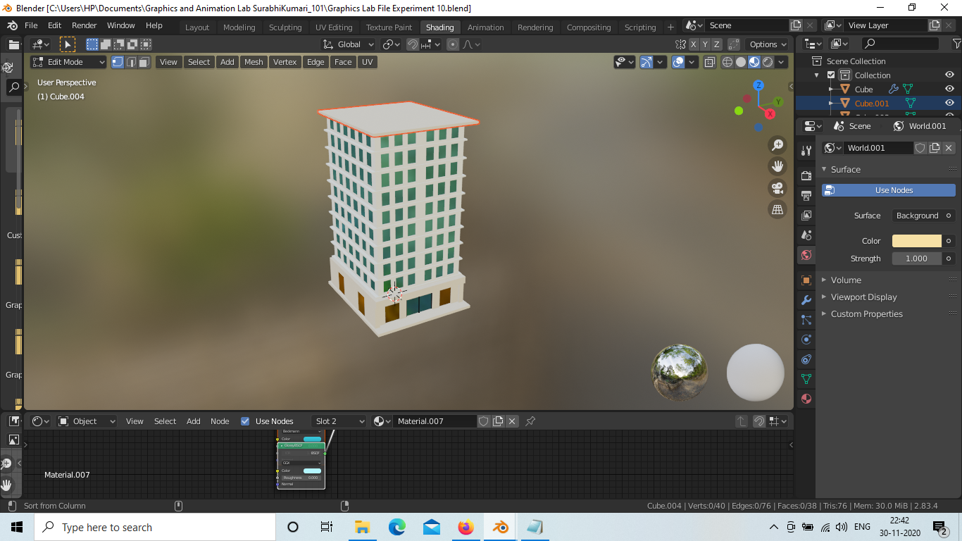

[Link for the Project](https://drive.google.com/drive/folders/1Q0Obfa_5wmu0ex1xFzSE15ilvbsG1ASU?usp=sharing)